**PRACTICAL 1**

**AIM: Installation and configuration of Instant Contiki OS with Cooja.**

**INSTALLATION:**

Step 1: Download Instant Contiki.

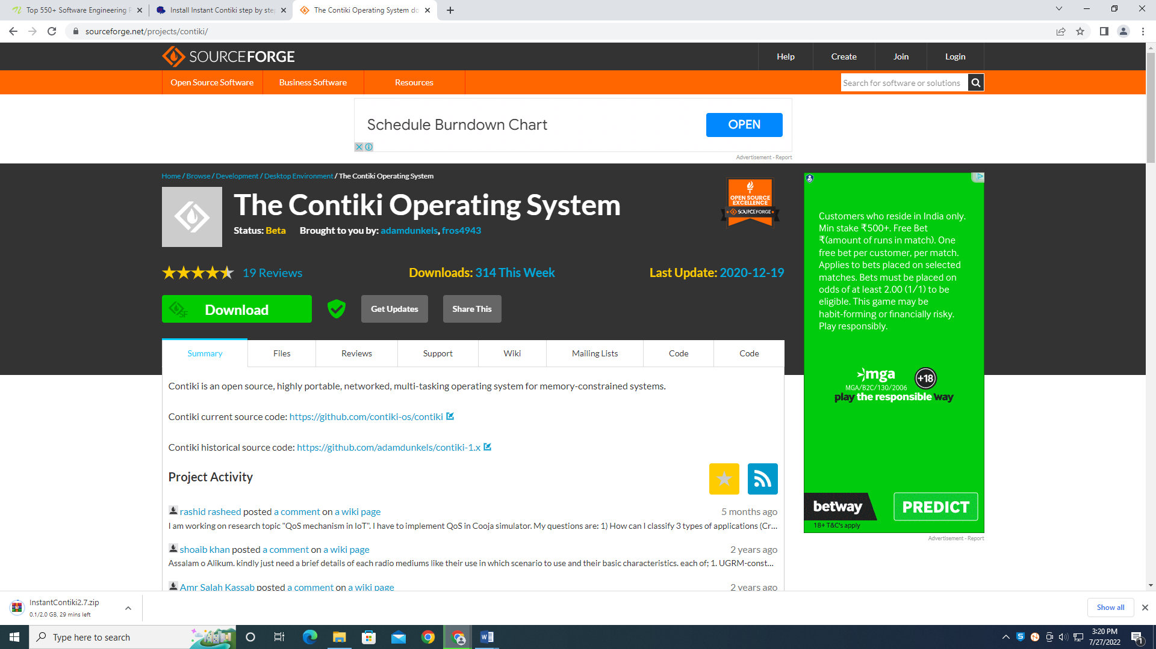

Step 2: Unzip the downloaded file.

Step 3: Start your virtualization software [Vmware](https://my.vmware.com/en/web/vmware/info/slug/desktop_end_user_computing/vmware_workstation_pro/15_0)  and load your Instant Contiki File. In Vmware click Open a Virtual Machine as shown below.

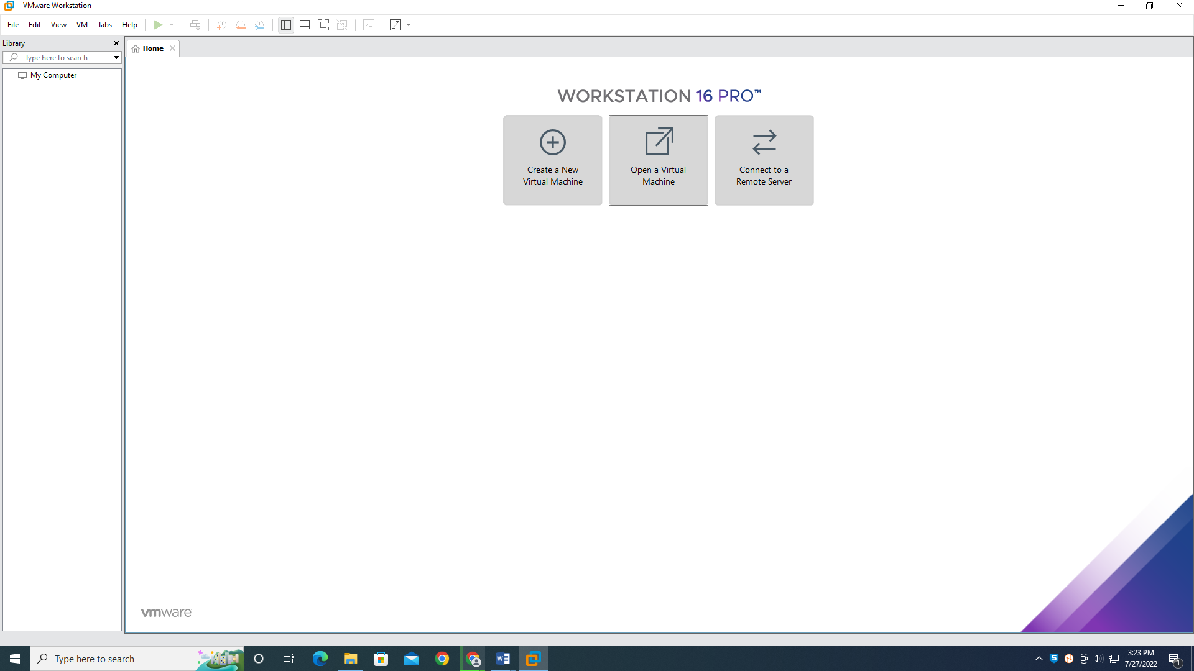

Step 4: Navigate to the extracted folder .vmx file.

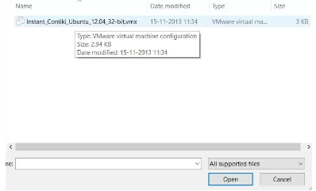

Step 5: Power on the machine.

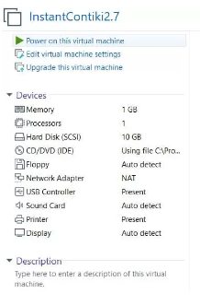

Step 6: Select “I Copied it” option.

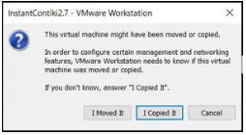

Step 7: Enter the password “user” and login to the Instant Contiki OS.

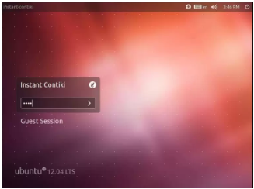

**PRACTICAL 2**

**AIM: Study of different types of motes and deploy them using IoT architecture. Simulate Hello World program using Cooja.**

**IMPLEMENTATION:**

Step 1: Create new simulation. Name the simulation.

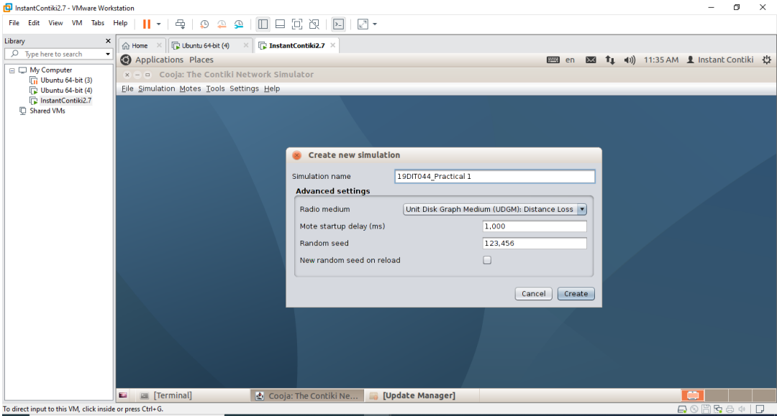

Step 2: We get an output screen shown in the screenshot.

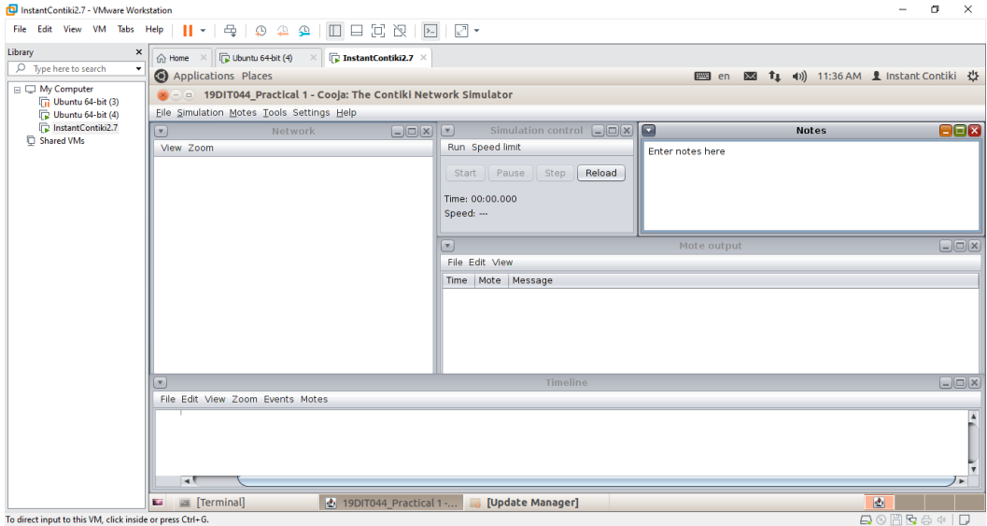

Step 3: Navigate to Motes > Add motes > Sky mote. Now you will get a new panel as shown below

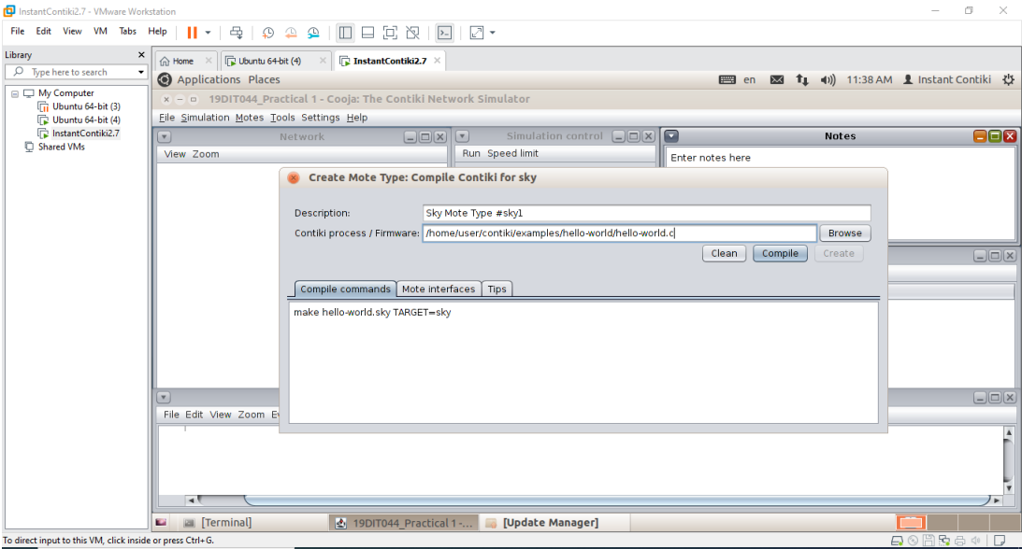

Step 4: Click browse and navigate to contiki-2.7/examples/hello-world/hello-world.c and press Compile.

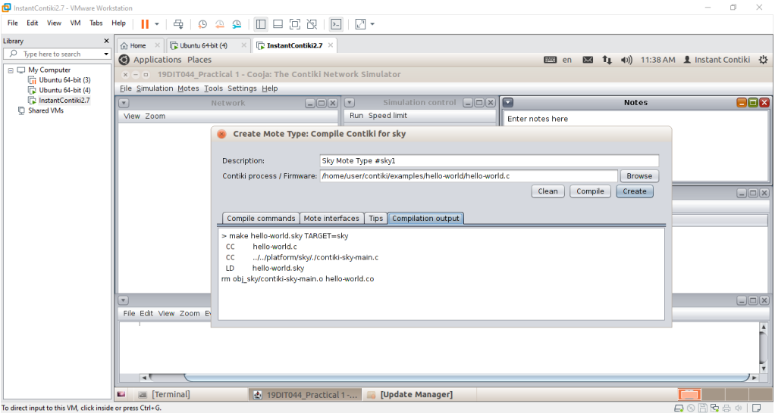

Step 5: After compilation press the Create button. You will get an option to add motes. Add 5 motes.

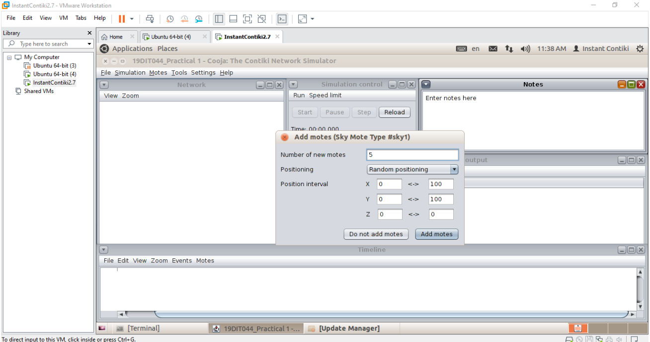

Step 6: You will get an output screen.

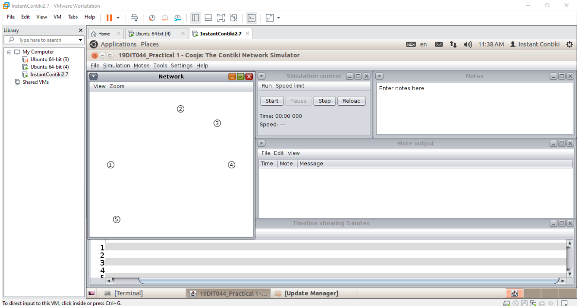

Step 7: Now click on View and select Mote IDs, Log output: printf()’s, LEDs, Radio Traffic, 10m

background grid, Mote Type and Radio environment. And start the simulation.

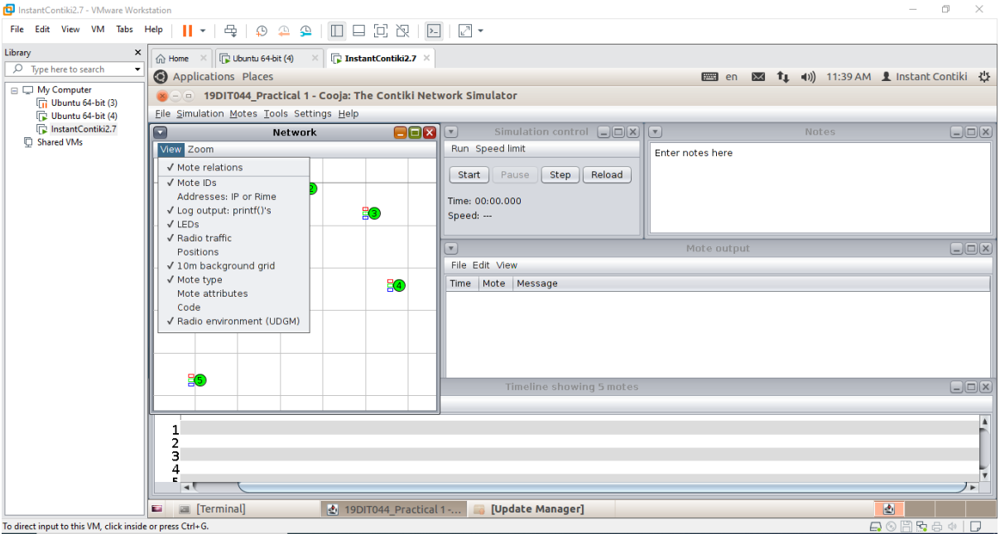

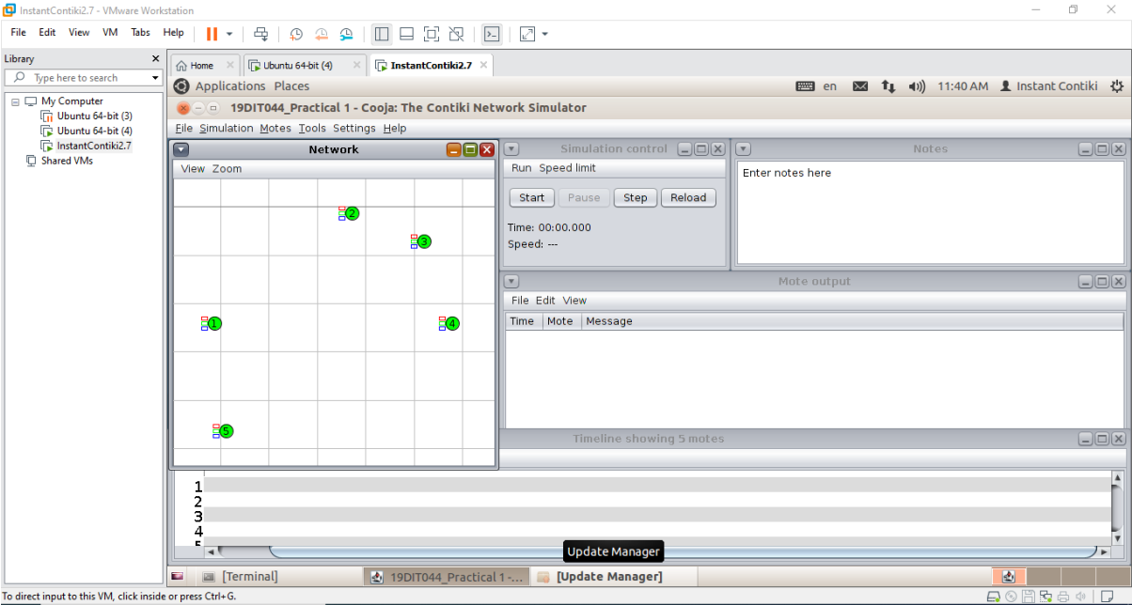

Step 8: Final output looks like in the screenshot.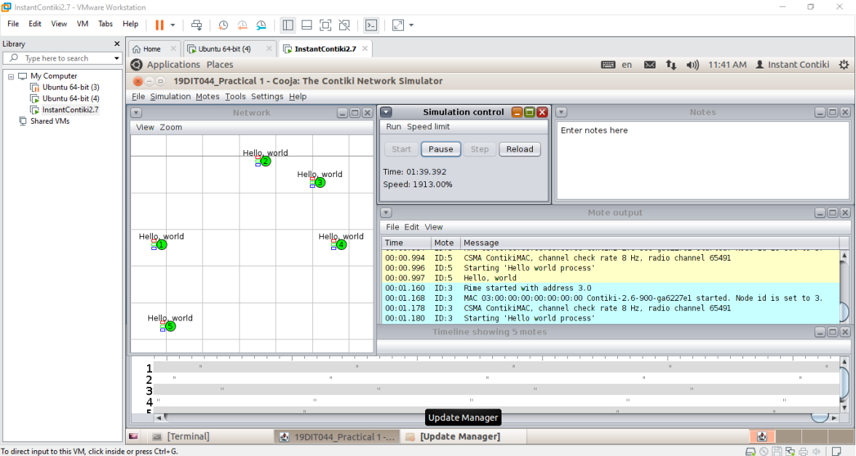

**OUTPUT:**

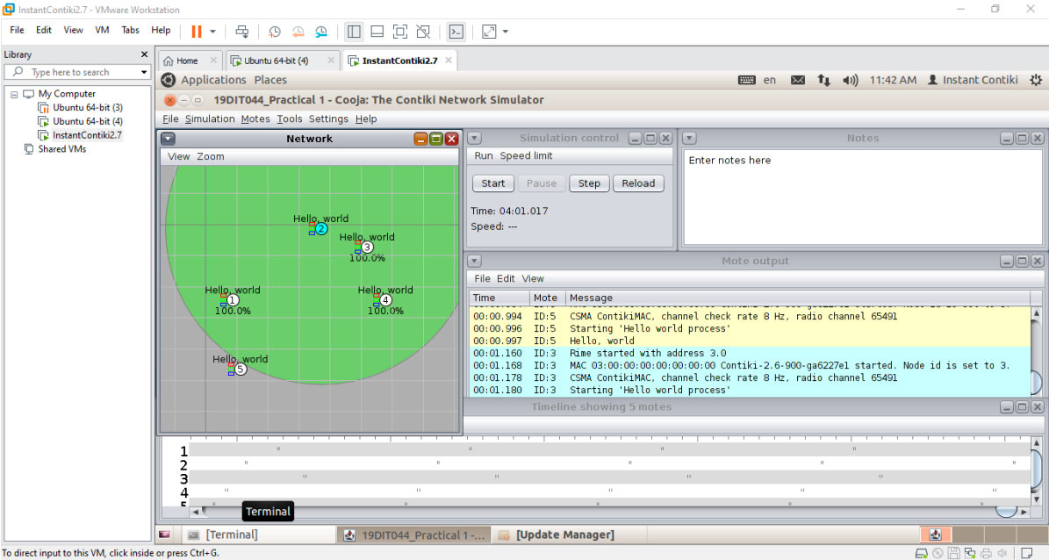

**CONCLUSION:**

From this practical, I learned about how to simulate a C program in Instant Contiki OS with Cooja.

Also I explored various views of the network.